QN NO:01

Coding:

package ca;

import java.util.List;

import org.openqa.selenium.By;

import org.openqa.selenium.JavascriptExecutor;

import org.openqa.selenium.WebDriver;

import org.openqa.selenium.WebElement;

import org.openqa.selenium.chrome.ChromeDriver;

import org.openqa.selenium.chrome.ChromeOptions;

import org.openqa.selenium.edge.EdgeDriver;

import org.openqa.selenium.interactions.Actions;

import org.openqa.selenium.support.ui.Select;

import dev.failsafe.internal.util.Assert;

import io.github.bonigarcia.wdm.WebDriverManager;

public class one {

public static void main( String[] args ) throws InterruptedException

{

//WebDriverManager.chromedriver().setup();

System.*setProperty*("webdriver.chrome.driver", "c://drivers//chromedriver.exe");

ChromeOptions co=new ChromeOptions();

co.addArguments("--remote-allow-origins=*");

WebDriver driver=new ChromeDriver(co);

driver.manage().window().maximize();

driver.get("https://www.amazon.in/Anne-Diamond-Analog-Womens-Watch-AK3686BKGB/dp/B0968Q7L3M/ref=sr_1_1_sspa?crid=293FS4VHUVN6K&keywords=watches&qid=1681287782&sprefix=watches%2Caps%2C323&sr=8-1-spons&sp_csd=d2lkZ2V0TmFtZT1zcF9hdGY&psc=1");

driver.findElement(By.*id*("add-to-cart-button")).submit();

String t=driver.getTitle();

System.***out***.println(t);

String cart=driver.findElement(By.*xpath*("//*[@id=\"NATC_SMART_WAGON_CONF_MSG_SUCCESS\"]/span")).getText();

if(cart.equals("Added to cart"));

System.***out***.println("1. Verified that Product added to cart ");

driver.navigate().back();

WebElement sort1=driver.findElement(By.*xpath*("//*[@id=\"quantity\"]"));

sort1.click();

Select select=new Select(sort1);

select.selectByIndex(1);

String drop=driver.findElement(By.*xpath*("//*[@id=\"quantity\"]")).getText();

if(drop.equals("2"));

System.***out***.println("3. Verified that Product is updated to cart ");

}

}

Output:

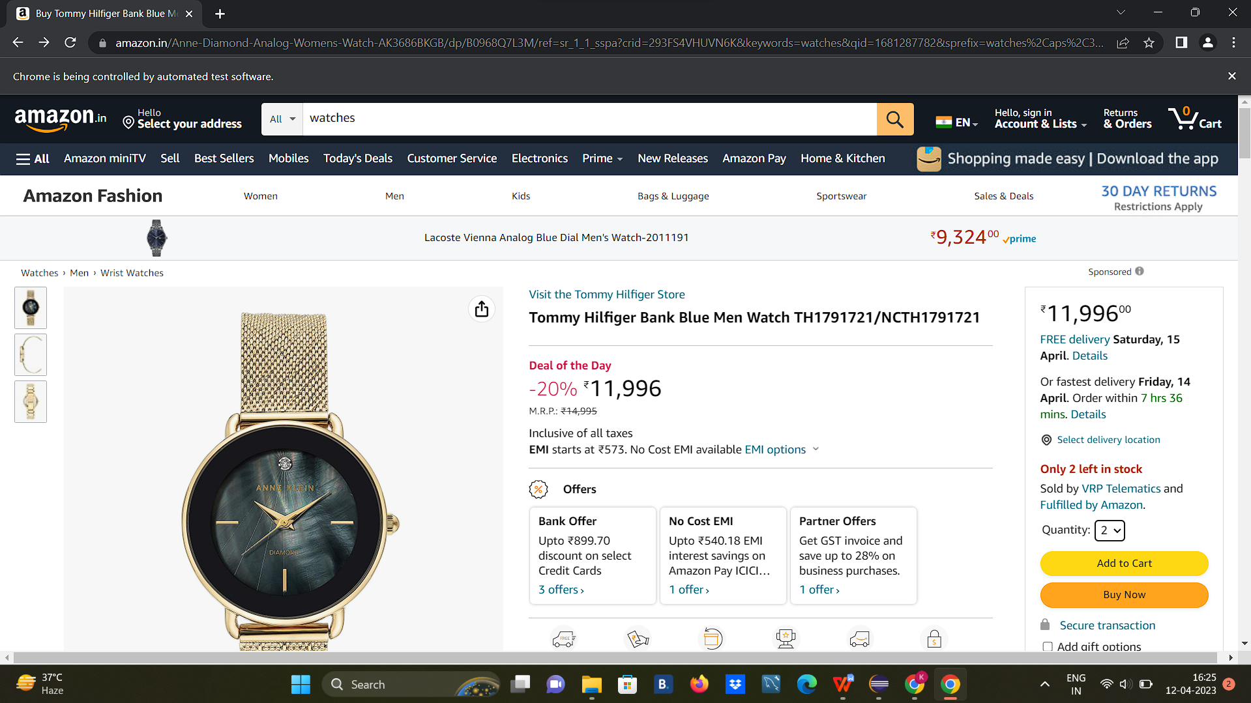

QN NO:02

Coding:

package ca;

import java.util.List;

import org.openqa.selenium.By;

import org.openqa.selenium.JavascriptExecutor;

import org.openqa.selenium.Keys;

import org.openqa.selenium.WebDriver;

import org.openqa.selenium.WebElement;

import org.openqa.selenium.chrome.ChromeDriver;

import org.openqa.selenium.chrome.ChromeOptions;

import org.openqa.selenium.support.ui.Select;

import io.github.bonigarcia.wdm.WebDriverManager;

public class two

{

public static void main( String[] args ) throws InterruptedException

{

//WebDriverManager.chromedriver().setup();

System.*setProperty*("webdriver.chrome.driver", "c://drivers//chromedriver.exe");

ChromeOptions co = new ChromeOptions();

co.addArguments("--remote-allow-origins=*");

WebDriver driver=new ChromeDriver(co);

driver.get("https://www.amazon.in/ref=nav_logo");

driver.manage().window().maximize();

String title=driver.getTitle();

System.***out***.println(title);

if(title.equals("Online Shopping site in India: Shop Online for Mobiles, Books, Watches, Shoes and More - Amazon.in")) {

System.***out***.println("Verified title of the page");

}else {

System.***out***.println("Title not matched");

}

driver.findElement(By.*id*("twotabsearchtextbox")).sendKeys("phone");

driver.findElement(By.*id*("twotabsearchtextbox")).sendKeys(*Keys*.***ENTER***);

System.***out***.println("Searched Item successfully");

driver.findElement(By.*id*("a-autoid-0-announce")).click();

List<WebElement>li=driver.findElements(By.*xpath*("//*[@id=\"octopus-dlp-asin-stream\"]/ul/li[2]/span/div/div[2]/div[1]/a"));

for(WebElement link:li) {

System.***out***.println(link.getText());

}

System.***out***.println("User is able to filter by search");

System.***out***.println("Testing Ended");

driver.quit();

}

}

Output:

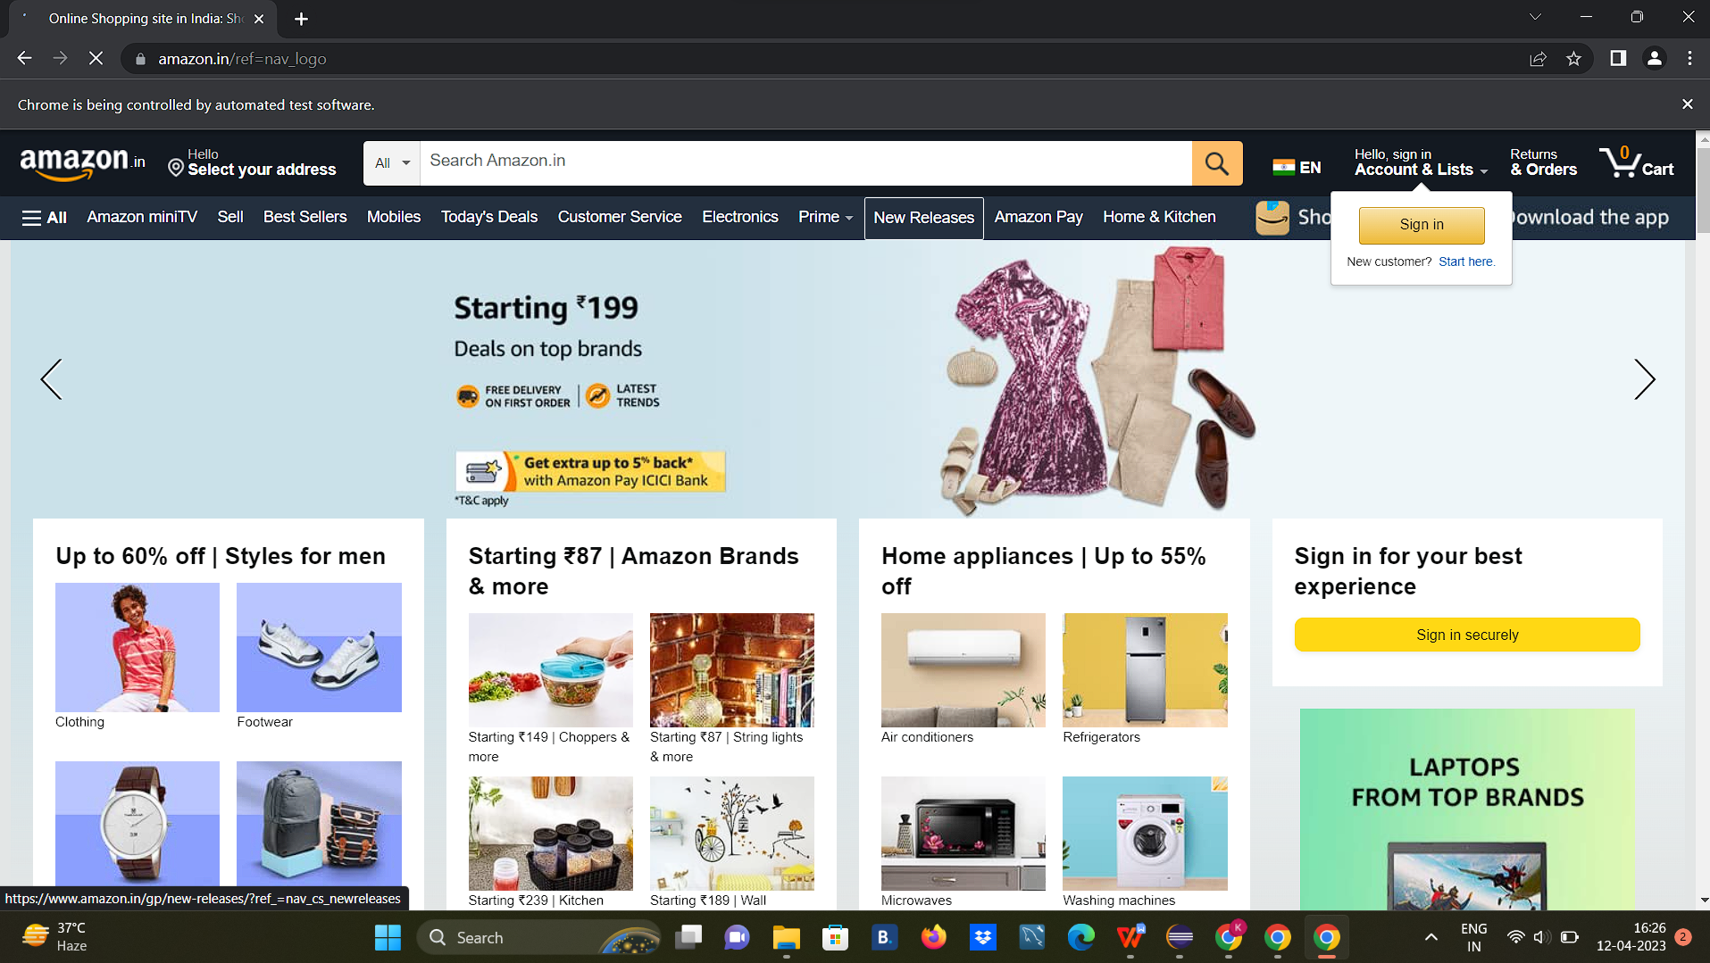

QN NO: 03

Coding:

package ca;

import java.util.List;

import org.openqa.selenium.By;

import org.openqa.selenium.JavascriptExecutor;

import org.openqa.selenium.Keys;

import org.openqa.selenium.WebDriver;

import org.openqa.selenium.WebElement;

import org.openqa.selenium.chrome.ChromeDriver;

import org.openqa.selenium.chrome.ChromeOptions;

import org.openqa.selenium.support.ui.Select;

import io.github.bonigarcia.wdm.WebDriverManager;

/**

* Hello world!

*

*/

public class Three

{

public static void main( String[] args ) throws InterruptedException

{

//WebDriverManager.chromedriver().setup();

System.*setProperty*("webdriver.chrome.driver", "c://drivers//chromedriver.exe");

ChromeOptions co = new ChromeOptions();

co.addArguments("--remote-allow-origins=*");

WebDriver driver=new ChromeDriver(co);

driver.get("https://www.amazon.in/ref=nav_logo");

driver.manage().window().maximize();

String title=driver.getTitle();

System.***out***.println(title);

if(title.equals("Online Shopping site in India: Shop Online for Mobiles, Books, Watches, Shoes and More - Amazon.in")) {

System.***out***.println("Verified title of the page");

}else {

System.***out***.println("Title not matched");

}

driver.findElement(By.*id*("nav-link-accountList")).click();

driver.findElement(By.*id*("ap_email")).sendKeys("727721euit072@gmail.com");

driver.findElement(By.*id*("ap_email")).sendKeys(*Keys*.***ENTER***);

driver.findElement(By.*id*("ap_password")).sendKeys("khan786*");

driver.findElement(By.*id*("ap_password")).sendKeys(*Keys*.***ENTER***);

Thread.*sleep*(2000);

String name=driver.findElement(By.*id*("nav-link-accountList-nav-line-1")).getText();

if(name.equals("Hello, Feviliya")) {

System.***out***.println("Successfully, signed in");

}else {

System.***out***.println("Sign in failed");

}

System.***out***.println("Testing Ended");

driver.quit();

}

}

Output:

